CSP Welsh Board Newsletter
March 2023
Meeting held virtually 23.03.23

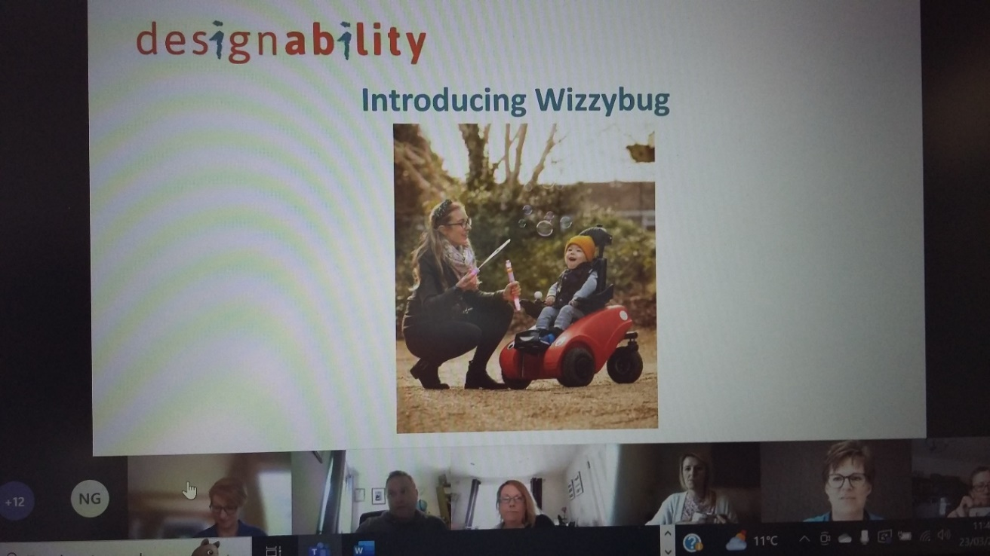

CSP Welsh Board heard an excellent presentation from Lucy Norris from ‘Designability’ about Wizzybug. Find out more about wizzybugs here: https://designability.org.uk/meet-wizzybug/
Update on Senedd and Welsh Gov issues
Calum highlighted the WG Health Workforce Implementation Plan - Design Team Style Template (gov.wales) and updated WB on the situation regarding the bursary for students entering employment (streamlining!). A consultation will be forthcoming – watch this space!

For Note.
Have you heard about the CSP’s Physiotherapy Informatics Strategy? (PHIS)
https://www.csp.org.uk/professional-clinical/digital-physiotherapy/physiotherapy-health-informatics-strategy
This will be very useful for members around all things ‘digital’

‘Collaborate, Don’t Compete’ - https://www.csp.org.uk/campaigns-influencing/shaping-healthcare/supporting-development-clinical-exercise-physiologist-faqs The CSP has developed resources around developing relationships with Clinical Exercise Physiologists

Concurrent Treatment - https://www.csp.org.uk/publications/concurrent-subsequent-treatment-advice-physiotherapists-working-nhs-private-sectors
This professional guidance paper has recently been updated

For Note.

‘State of the Nation’ event in the Senedd – 27th of June 2023

Calum informed the WB that the CSP will be holding an event in the Norwegian Church which will provide a platform to launch the CSP’s Rehabilitation Standards.

The event will be aimed at politicians and stakeholders.

It will be a chance to highlight issues raised by members concerning rehabilitation services. For Note.

CSP Annual Conference 2023 – coming to Cardiff!
Physiotherapy: Transforming Population Health
https://www.csp.org.uk/conference #Physio23
26th of October in the Marriot Hotel, Cardiff
£39.00 for members - £29.00 for student/retired/unwaged. (Early bird offer ends April 12th)
CSP Welsh Board has had an opportunity to shape the development of the day and the programme is looking good! Calum has created a recording about the Welsh Government’s ‘6 goals for urgent and emergency care’ to support the development of the programme – coming soon – see the CSP Wales page https://www.csp.org.uk/networks/nations-regions/wales
Programme themes: i) Accelerating improvement, ii) Evolving practice, iii) Essential rehabilitation, iv) Education and innovation.
Sign up today! For Action.

NHS Pay – Adam Morgan SNO briefed the WB
Make sure you are up to date with what is happening on the pay deal in Wales.
The CSP has a dedicated pay page outlining the situation in all parts of the UK.
https://www.csp.org.uk/workplace/pay-and-conditions/nhs-pay-proposals

It is a complicated picture, especially as there have been varying offers in different parts of the UK. Keep in touch with your steward and make sure you do not miss any consultations and future webinars. For Action.

CSP Welsh Board wants to hear from professional networks that are active in Wales – let us know!
If you help to organise/run any clinical networks in Wales please get in touch so that WB can share newsletters and information with you for cascade.

Developing links will mean a chance for WB to hear from your network and find out about some of the excellent work your network members are doing across Wales.
Come and make a presentation to the Board.

Please get in touch via Jenny Francis francisj@csp.org.uk
For Action.
Goodbye Hannah Morley!

It was Hannah’s last meeting with the Board and everyone wanted to wish her all the best for her new job in Aneurin Bevan Health Board. They also wanted to thank her for the fantastic job she has done for the CSP in Wales.

Thanks Hannah – we will miss you!

Are you a CSP member?
This newsletter provides some useful resources and feedback – but if you were a member of the CSP you would get so much more! The CSP is there for physios, support workers and students. If you are not a member… why not? Join the CSP now! https://www.csp.org.uk/join-csp
For Action.
Update from the Welsh Allied Health Professions Committee (WAHPC)
Hot topics continue to be the AHP Awards, the AHP Workforce Review and the Rehabilitation Modelling tool.

‘Fit Notes’ – AHPs can now issue these but they must have undertaken appropriate training. The CSP has guidance on this - https://www.csp.org.uk/professional-clinical/professional-guidance/fitness-work/fit-notes

For Note.
(WAHPC Continued…)

Duty of Candour and Duty of Quality
These are now coming into operation in Wales and members need to be aware of the implications for clinicians and service users. WB is planning to run a training on this and then cascade to members.

For more detail contact Non Griffiths non.griffiths2@wales.nhs.uk

For Note.

Want to know more about CSP Welsh Board? If you want to know more or wish to become involved please contact your local WB rep or a member of the exec. It may be possible for you to attend a WB meeting as an observer with the agreement of the WB exec.
Reps: https://www.csp.org.uk/system/files/documents/2022-12/csp_welsh_board_-_whos_who_2022_2.pdf
For Note and Action.

Lots of fantastic resources for CSP Associate Members!
Are you accessing all the resources on the CSP Website?
https://www.csp.org.uk/networks/associates-support-workers

@CSPWales team is supporting the development of the Support Worker voice within Wales.

Have you seen the CSP’s short film? #ThinkingDifferently
https://www.csp.org.uk/networks/associates-support-workers/thinking-differently-about-support-workers
To use and share.

Keeping in touch with the CSP in Wales?
Are you following @CSPWales on twitter?

Are you following the ‘team CSP Wales’ officers on twitter?
@CalumCSP – Calum Higgins, Public Affairs and Policy Manager for Wales
@AdamM_CSP – CSP Senior Negotiating Officer for Wales and West Midlands
Vacancy – CSP Professional Advisor in Wales
@CSPHayley – Campaigns and Regional Engagement Officer for Wales
@JennyFrancis88 – CSP Administrator in Wales
@physiospilz – Alice Spilsbury, ERUS Organising Officer for Wales and West Midlands

Are you signed up to receive regular CSP bulletins? Make sure your details are up to date on the CSP website and you have signed up to all the i-CSP bulletins you want to receive. There’s loads of valuable information and peer support that you can tap into from the CSP and i-CSP from other members that you link with via networks.

Living and working in Wales, you will be part of the Wales network – and you will receive the regular ‘Wales regional bulletin’.

