CSP Welsh Board Newsletter
December 2022
Meeting held ‘in person’ 06.12.22

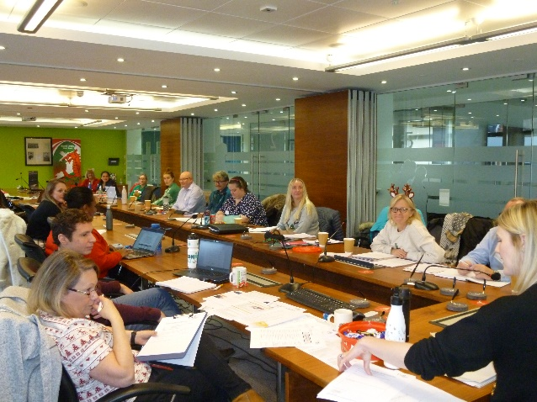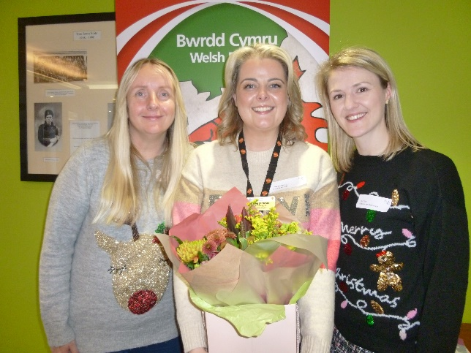

(CSP Welsh Board at work) (Sheryl – Vice Chair, Indeg and Cat Chair of WB)
CSP Welsh Board met in person in Cardiff on the 6th of December 2022. The Board said a fond farewell to Indeg Jameson, South West Wales rep, who is stepping down from her role and thanked her for her huge contribution. Indeg has been involved with the Board since being a student rep! We have loved her journey and know that she will stay involved. Diolch Indeg we will miss you but know you will stay in touch!
National Physiotherapy Conference 2023 – Coming to Cardiff 26th of October, Marriot Hotel – Date for your diaries.
Calls for abstracts will be coming out soon! Look out for this – Welsh Board will send alerts via the networks. We want to see plenty of submissions from all across Wales. CSP will be looking for posters, ‘Rapid 5’ presentations and platform presentations. There is amazing work happening in Wales – make sure you get the chance to showcase it!
For Action.
Nursing Strike Action
Important information for members
Physiotherapy staff should NOT be undertaking nursing roles or tasks that are outside your contract. If you experience issues around this alert your workplace steward. CSP wants to know about any problems – wales@csp.org.uk

For Action.
Supporting Nursing Colleagues on Strike
Advice to members
CSP members are encouraged to support their nursing colleagues and greet and encourage them on their picket line to show solidarity but ONLY outside of normal contracted hours of employment.

For Action.
Rehabilitation Framework for Wales
https://gov.wales/sites/default/files/publications/2022-10/all-wales-rehabilitation-framework.pdf
Have you seen this Framework?
If you work in rehabilitation – how do your services fit into the framework?
There are lots of useful resources associated with the framework and it will be a significant priority for the Welsh Allied Health Professions Committee (WAHPC) and Welsh Government.
How have your rehabilitation services changed and transformed? Let Non Griffiths the WAHPC rep know – we need to provide lots of examples to Welsh Government of how physiotherapy (along with other AHP professions) are providing solutions – preventing admission, shortening hospital stay and improving rehab at home. Contact non.griffiths2@wales.nhs.uk Welsh Board really wants to hear about what is happening out there and how your services are making a difference to patients right across Wales!

For Action.

Primary Care developments in Wales
Do you know about the Strategic Programme for Primary Care and the Communities of Practice?

If you work in the community or if you are a First Contact Practitioner working within primary care clusters you will find these resources very useful.

Strategic Programme for Primary Care and the new Community Infrastructure (CI) toolkit. https://primarycareone.nhs.wales/topics1/strategic-programme/

For Note.

Primary Care

Members are recommended to sign up to the ‘Communities of Practice’ Newsletter https://ipc.brookes.ac.uk/images/LI503834-A-Healthier-Wales-Communities-of-Practice-Newsletter-English-Sept-2022.pdf

For those working in community and primary care there are a range of multi-professional groups that have been set up to consider clinical practice and provide support and learning.

It is very important that all AHPs working in primary and community care link in to support service development and highlight developments.

For Action.

Workforce Strategy Implementation Plan for Wales – Phase 2

This plan is going into its second phase.
Have you heard about it?
Have you heard about the workforce organising principles?
Always worth having a look at these to see what they mean to you.
https://heiw.nhs.wales/workforce/workforce-planning-and-information/principles-to-underpin-workforce-planning-for-nhs-wales/
If we want to expand the physiotherapy workforce, grow the support worker workforce, and expand the training of the workforce of the future, we need to use these principles and know about the strategy.

For information and use.

Message from the Chief AHP Advisor to Welsh Government
Ruth Crowder, the Chief AHP Advisor to Welsh Government is keen to hear about examples of practice that demonstrate the Welsh Government 6 goals for urgent and emergency care.
https://gov.wales/six-goals-urgent-and-emergency-care-policy-handbook-2021-2026
Have you heard about these? How are your services responding to managing urgent and emergency care for patients? Have you got some great examples to share? Ruth would like to hear about them as would Non Griffiths the CSP Welsh rep on WAHPC non.griffiths2@wales.nhs.uk There is a chance here to invite the Therapy Advisor and possibly the Minister for Health and Social Care, Eluned Morgan MS to visit your services.
Do get in touch – and consider submitting examples as abstracts to the National Physiotherapy Conference in Cardiff, in October 2023.
For Action.

Private Practice Physiotherapists in Wales
CSP Welsh board has set up a peer network for you. If you would like to be involved then contact the Board private practice rep Maria Lewis reachyourpeakonline@mail.com
There has already been a couple of virtual meetings and a community of around 30 members engaged to date. Great to hear feedback from the private practitioners in Wales!
There are plenty of resources available from the CSP for you – look here….
https://www.csp.org.uk/networks/independent-practitioners

For Action.

Barriers to collaborative/concurrent working between private and NHS Physios
This issue was raised at CSP Welsh Board and it was acknowledged that it continues to be source of contention in some areas.

There is a CSP guidance paper on this area that will be of importance to members.
https://www.csp.org.uk/publications/concurrent-subsequent-treatment-advice-physiotherapists-working-nhs-private-sectors
It was agreed to flag up the concern with HBs and check the policies being used in the NHS.

For Action.

Are you a CSP member?
This newsletter provides some useful resources and feedback – but if you were a member of the CSP you would get so much more! The CSP is there for physios, support workers and students. If you are not a member… why not? Join the CSP now! https://www.csp.org.uk/join-csp

For Action.
Associate Members – resources for you
https://www.csp.org.uk/networks/associates-support-workers
Fantastic resource area of the CSP website for our associate members – check it out!

For Action.

Who represents you on CSP Welsh Board?
Do you know who represents you on CSP Welsh Board?
Find out here…
https://www.csp.org.uk/networks/nations-regions/wales/welsh-board
For note.

Keeping in touch with CSP Welsh Board and the CSP
Are you following @CSPWales on twitter?

Are you following the ‘team CSP Wales’ officers on twitter?
@CalumCSP – Calum Higgins, Public Affairs and Policy Manager for Wales
@AdamM_CSP – CSP Senior Negotiating Officer for Wales and West Midlands
@HannahMorleyNHS – CSP Professional Advisor in Wales
@CSPHayley – Campaigns and Regional Engagement Officer for Wales
@JennyFrancis88 – CSP Administrator in Wales
@physiospilz – Alice Spilsbury, ERUS Organising Officer for Wales and West Midlands

Are you signed up to receive regular CSP bulletins? Make sure your details are up to date on the CSP website and you have signed up to all the i-CSP bulletins you want to receive. There’s loads of valuable information and peer support that you can tap into from the CSP and i-CSP from other members that you link with via networks.

Living and working in Wales, you will be part of the Wales network – and you will receive the regular ‘Wales regional bulletin’.

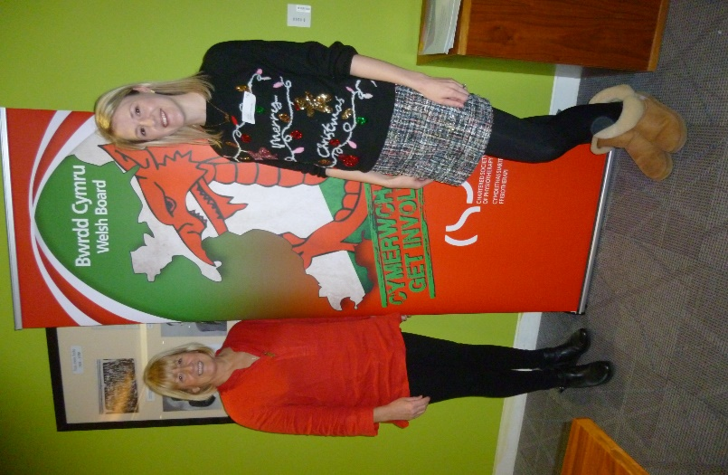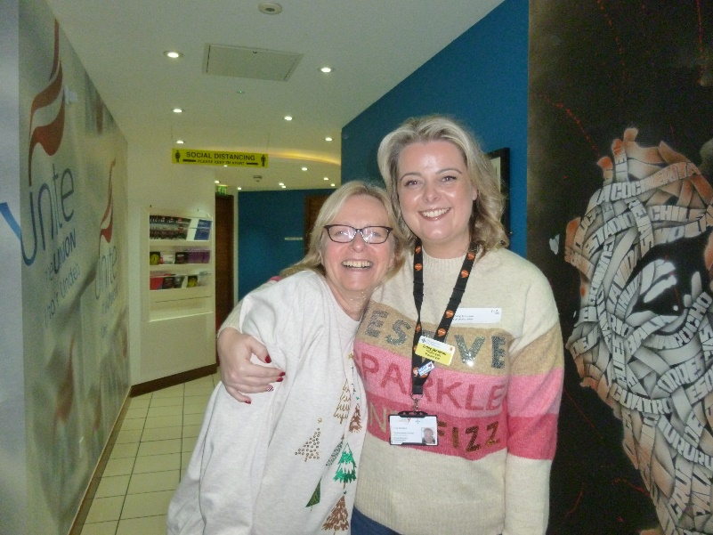

(Ruth and /Cat) (Non and Indeg)

