Infection Control Policy

Version:

Date:

Contents
Introduction 3
Management Responsibilities 3
Therapist Responsibilities 3
Standard Infection Control Precautions 4
Hand Hygiene 4
Introduction 4
Hand Hygiene (Hand Washing) Procedures 5
Preparation 5
Hand Washing Technique with Soap and Water 5
Hand Washing Technique Using Alcohol-Based Hand Rub for Visibly Clean Hands 6
Additional Points to Note 6
Hand Care 6
Hand Hygiene and Jewellery 7
Respiratory Hygiene/Cough Etiquette 7
Personal Protective Equipment 7
Occupational Exposure Management Including Needlestick (“Sharps”) Injuries. 7
Good Sharps Practice 8
What is Meant by Occupational Exposure Including Needlestick (Or “Sharps”) Injury? 8
Actions in the Event of an Occupational Exposure Including Needlestick or Similar injury 8
Reporting an incident or Near Miss 8
Management of Electrotherapy Equipment 8
Safe Management of Linen 9
Care of Uniforms 9
General Good Practice Advice 9
Room Cleaning Policy 9
Safe Waste Management 10
Procedure for dealing with infectious diseases 10
Document Control Details 10

Introduction
It is the responsibility of all healthcare staff to minimise the potential risk of patients acquiring a healthcare associated infection during treatment at <insert clinic name>. This policy has been developed in accordance with the Department of Health guidelines; -
- Clean Safe Care, Reducing Infections and Saving Lives” (DH 2008)
- The Health & Social Care Act 2009, “Code of Practice for Health and Adult Social Care on the Prevention and Control of Infections and Related Guidance” (DH 2009)
This has recently been updated in accordance with the NICE Guidelines; -
- CG139 Prevention and Control of Healthcare-Associated Infections Pathway” (NICE 2012).

Management Responsibilities
The Clinic Director(s), <insert name(s)> are responsible for ensuring that effective infection control arrangements are in place within the organisation and that these are subject to annual review. They have further delegated these tasks to the Operations Manager and Clinic managers.
All therapists have standard procedures to follow in the event of an outbreak of an infectious disease or if they come into contact with an infectious person and can also seek guidance from the clinic manager at any time.
Any issues regarding infection prevention and control will be documented by the Clinic Managers and the information used to inform future policy developments.
All Healthcare Professionals will receive training on infection control on induction, annually or if any incidents highlight the need for further training.
Healthcare Professionals are supplied with an agreed number of uniforms and must wear a clean uniform daily. If the clothing is soiled during a treatment, then the Healthcare Professional must change their uniform as soon as possible and before any contact with another patient.
Any students at <insert clinic name> will also adhere to this policy.

Therapist Responsibilities
Every Healthcare Professionals has a responsibility to; -
- Deliver healthcare to his/her patients in the safest and most effective way possible.
- Make themselves aware of the contents of this policy and associated guidelines.
- Bring to the attention of their Clinic Manager any issues regarding infection control
- Encourage patients, carers, visitors and other staff to comply with the principles of infection control precautions
- Comply with any infection prevention and control training
- Report any illness which may be because of occupational exposure, to their Clinic Manager
- Not provide direct patient care while infectious and if in any doubt consult their Clinic Manager
- To see infection control principles as an objective within continuing professional development.
- Comply with local and national policies, procedures and campaigns regarding infection control precautions.

Standard Infection Control Precautions
Healthcare professionals working at <insert clinic name> have a responsibility to minimise exposure to and transmission of potential micro-organisms from both recognised and unrecognised sources by the following methods; -
- Use effective hand hygiene
- Not wearing jewellery on the hands or wrists
- Make sure fingernails are short, clean and free of nail polish
- Be bare below the elbow when delivering direct patient care
- Cover cuts and abrasions with waterproof dressings
- Treat all blood and body fluids as infected
- Wear protective clothing when dealing with any body fluids and substances hazardous to health
- Use and dispose of sharps safely
- Manage equipment used appropriately to limit the risk of contamination with microorganisms.
- Adhere to local Environmental Hygiene Policy including dealing promptly with body fluid spillages
- Dispose of clinical waste correctly and safely (if appropriate)
- Manage any linen used appropriately to limit the risk of contamination with microorganisms

Hand Hygiene

Introduction
Hands are the most common way in which micro-organisms, particularly bacteria, might be transported and subsequently cause infections, especially in those who are most susceptible to infection.

Good hand hygiene is the most important practice in reducing transmission of infectious agents, including Healthcare Associated Infections (HCAI) during delivery of care.

The term hand hygiene refers to all processes, including hand washing using soap and water and hand decontamination achieved using other solutions e.g. alcohol hand rub.

Levels of hand hygiene | Why perform hand hygiene?
LEVEL 1  Social Hand Hygiene | To render the hands physically clean and to remove microorganisms picked up during activities considered ‘social’ activities (transient Micro-organisms)
LEVEL 2 Hygienic  (aseptic) Hand Hygiene | To remove or destroy transient Micro-organisms. Also, to provide residual effect during times when hygiene is particularly important in protecting yourself and others (reduces resident micro-organisms which normally live on the skin)

Before patient contact | When? Clean your hands before touching a patient when approaching him/her  Why? To protect the patient against harmful germs carried on your hands
Before a clean/aseptic task | When? Clean your hands immediately before any clean/aseptic task  Why? To protect the patient against harmful germs, including the patient’s own, from entering his/her body
After body fluid exposure risk | When? Clean your hands immediately after an exposure risk to body fluids (and after glove removal)  Why? To protect yourself and the healthcare environment from harmful patient germs
After patient contact | When? Clean your hands after touching a patient and his/her immediate surroundings when leaving the patient’s side  Why? To protect yourself and the healthcare environment from harmful patient germs
After contact with patient surroundings | When? Clean your hands after touching any object or furniture in the patient’s immediate surroundings when leaving- even if the patient has not been touched  Why? To protect yourself and the healthcare environment from harmful patient germs

Hand Hygiene (Hand Washing) Procedures
Hand hygiene should be performed for between 15 seconds and 3 minutes depending on the level of hand hygiene being performed. Washing for longer than these times is not recommended as this may damage the skin leading to increased shedding of skin scales and increased harbouring of micro-organisms.

Preparation
- Ensure that everything which is needed to perform hand hygiene is present
- Ensure the area is free from extraneous items, e.g. medicine cups, utensils
- Ensure jackets/coats are removed, and wrists and forearms are exposed
- Jewellery must be removed
- Ensure nails are short (false nails must not be worn)

Hand Washing Technique with Soap and Water
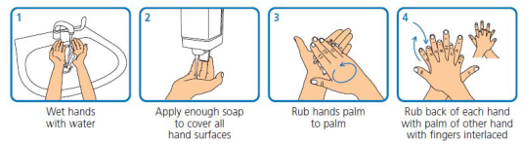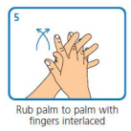
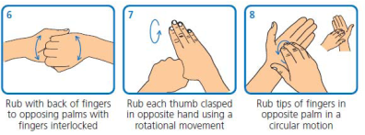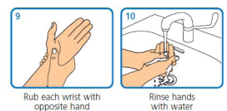
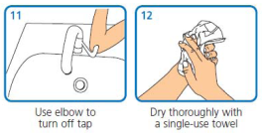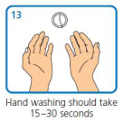

Hand Washing Technique Using Alcohol-Based Hand Rub for Visibly Clean Hands
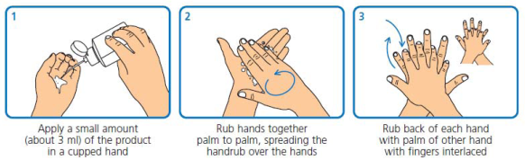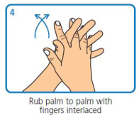

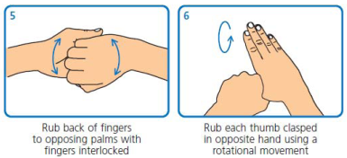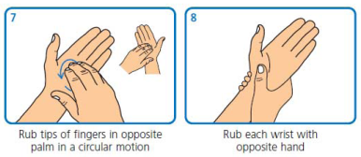

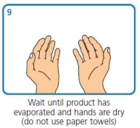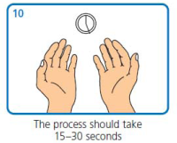

Additional Points to Note
- Dispose of the paper towels without re-contaminating your hands e.g. use the foot pedal.
- Nailbrushes must not be used to perform hand hygiene
- If hands have patient contact but are not soiled with any body fluids and therefore do not require re-hand washing with soap or an antiseptic hand cleanser, then alcohol-based hand rub can be used.
- Where infection with a spore forming organism (e.g. Clostridium difficile) or with a gastroenteritis virus (e.g. Norovirus) is suspected or proven, hand hygiene must be carried out with liquid soap and water, although it can be followed by alcohol-based hand rub.
- Bar soap must not be used by staff for hands
- Solutions used may vary but the physical actions of performing hand hygiene should be the same

Hand Care
Hand care is important to protect the skin from drying and cracking. Cracked skin may encourage micro-organisms to collect and broken areas can become contaminated, particularly when exposed to blood and body fluids.

Hand creams can be applied to care for the skin on hands. However, only individual tubes of hand cream for single person use or hand cream from wall mounted dispensers should be used. Communal tubs must be avoided as these may contain bacteria over time, and lead to contamination of hands.

Hand Hygiene and Jewellery
It has been shown that contamination of jewellery, particularly rings with stones or intricate jewellery can occur. Jewellery must be removed when working in clinical care settings to prevent the spread of micro-organisms. Jewellery should be removed at the start of the working day though it is acceptable to wear plain wedding bands which must be removed when hand washing.

Respiratory Hygiene/Cough Etiquette
Respiratory hygiene and cough etiquette should always be applied which include:
- Cover nose and mouth with disposable single use tissues when sneezing, coughing and blowing noses
- Dispose of used tissues into a waste bin
- Wash hands with soap and water after coughing, sneezing, using tissues, or after contact with respiratory secretions or objects contaminated by these secretions
- Keep contaminated hands away from the mucous membranes of the eyes and nose

Personal Protective Equipment
As therapists do not carry out any invasive procedures there is no requirement to wear protective equipment. Gloves must be worn for invasive procedures and all activities that have been assessed as carrying a risk of exposure to blood, body fluids, secretions and excretions and when handling sharp or contaminated instruments.

Occupational Exposure Management Including Needlestick (“Sharps”) Injuries.
In order to avoid occupational exposure to potentially infectious agents, particularly those microorganisms that may be found in blood and other body fluids, precautions are essential while providing care. It must always be assumed that every person encountered could be carrying potentially harmful microorganisms that might be transmitted and cause harm to others. Therefore, precautions to prevent exposure to these and subsequent harm in others receiving or providing care must be taken as standard. Occupational exposure management, including needlestick (or “sharps”) injury, is one of the elements of Standard Infection Control Precautions (SICPs), which should be applied in all healthcare settings.

Needlestick (or “sharps) injuries are one of the most common types of injury to be reported to Occupational Health Services by healthcare staff. The greatest occupational risk of transmission of a Blood Borne Virus (BBV) is through parenteral exposure e.g. a needlestick injury, particularly hollow bore needles. Risks also exist from splashes of blood/body fluids/excretions/secretions (except sweat), particularly to mucous membranes; however, this risk is considered to be smaller. There is currently no evidence that BBVs can be transmitted through intact skin, inhalation or through the faecal-oral route. However, precautions are important to protect all who may be exposed, particularly when treatment for certain BBVs is not readily available. The risks of occupationally acquiring other infections are not as clearly documented; however Standard Infection Control Precautions (SICPs) should help to prevent exposure to other infectious agents.

The Acupunctured Associated of Chartered Physiotherapists (AACP) guidance upon finding a loose acupuncture needle is clearly displayed on the wall of treatment rooms where acupuncture is provided.

Good Sharps Practice
- Sharps should not be passed from hand to hand and handling should be kept to a minimum
- Once a sterile needle pack has been opened the needle must be used immediately
- Used sharps must be discarded into a sharp’s container conforming to UN3291 and BS 7320 standards
- Approved sharps containers should be assembled correctly and should never be over-filled, i.e. above the manufacturers’ fill line on the box/more than ¾ full.
- All sharps bins should be positioned out of reach of children at a height that enables safe disposal by all members of staff. They should be secured to avoid spillage.
- These containers should be appropriately sealed in accordance with manufacturers’ instructions once full and should be disposed of according to local clinical waste disposal policy.
- Items should never be removed from sharps containers. The temporary closure mechanism on sharps containers should be used in between use for safety.
- The label on the sharp’s containers must be completed when starting to use the container and again once sealed, to facilitate tracing if required.
- The safe carriage of sharp items is also essential when returning full sharps-bins to head-office, for example the sharps bin should be sealed and stored in the boot of the car.

What is Meant by Occupational Exposure Including Needlestick (Or “Sharps”) Injury?
By occupational exposure including needlestick (sharps) injury this guidance refers to the following injuries or exposures:
- Percutaneous injury (from needles, instruments, bone fragments, human bites which break the skin)
- Exposure of broken skin (abrasions, cuts, eczema, etc)
- Exposure of mucous membranes including the eye, nose and mouth

Actions in the Event of an Occupational Exposure Including Needlestick or Similar injury
Perform first aid to the exposed area immediately as follows:
Skin/tissues
- Skin/tissues should be gently encouraged to bleed. Do not scrub or suck the area.
- Wash/irrigate with soap and warm running water. Do not use disinfectants or alcohol.
- Cover the area using a waterproof dressing.
Eyes and mouth
- Eyes and mouth should be rinsed / irrigated with copious amounts of water.
- If contact lenses are worn, irrigation should be performed before and after removing these. Do not replace the contact lens.
- Do not swallow the water which has been used for mouth rinsing following mucocutaneous exposure.

Reporting an incident or Near Miss
The person who attended to the accident or incident must record the details as soon as possible on an accident and incident report form.

They must also immediately notify the management team who will ensure the form is fully completed and decide whether the incident requires reporting to the Health & Safety executive.

Urgency is important in these situations as post exposure prophylaxis (PEP) for HIV or other treatments may be required and ideally should be commenced within 1 hour of the incident.

Management of Electrotherapy Equipment
Electrotherapy equipment has direct contact and is therefore at high risk of transfer of micro-organisms.

How should electrotherapy equipment be stored?
- Electrotherapy equipment must be stored clean and dry following use.
- Equipment should also be checked for cleanliness prior to use
- Electrotherapy equipment should never be stored on the floor.
When to perform procedures for management of Electrotherapy Equipment
- On a routine, scheduled basis as detailed at local level
- When equipment is visibly dirty
- Immediately when spillages or contamination with blood/other body fluids has occurred

Safe Management of Linen
It has been shown that soiled fabric within healthcare settings can harbour large numbers of potentially pathogenic microorganisms, so it is important to ensure appropriate precautions are taken.
- Towels should be changed between patients if they come into direct contact with the patient.
- Paper roll can be used over towels and disposed of after each patient contact.
- Soiled Towels should be placed in the linen collection bag immediately.
- All towels must be changed at the end of each clinic
- All towels are laundered appropriately by an external company.

Care of Uniforms
It is not considered that uniforms are a serious source of infection though there are some good practice guidelines which can be followed to reduce the likelihood of cross contamination and these include:
- Wear soft-soled, closed toe shoes
- Change into a clean uniform at the start of each shift
- Wear short sleeved tops/shirts.
- Change immediately if clothes become heavily soiled or contaminated
- Wash uniforms at the hottest programme suitable for the fabric

General Good Practice Advice
- All staff must ensure that the occupational immunisations and clearance checks relevant to their practice are up to date (e.g. hepatitis B immunisation)
- Cuts and abrasions should be covered with a waterproof dressing before providing care.
- Staff with skin conditions should seek GP advice to minimise risk of infection through open skin lesions.
- All staff must wear gloves when exposed to blood, other body fluids, excretions, secretions, non-intact skin or contaminated wound dressings might occur
- Therapists must not wear open footwear.
- All staff must clean spillages of any body fluids or contaminated items immediately
- All staff must dispose of clinical waste immediately
- All staff should wear a clean uniform each day

Room Cleaning Policy
Clinic standards will be checked on an ongoing basis by clinic managers to ensure that <insert clinic name> room cleaning standards are maintained. We ask that all therapist note the below; -
- If there is a risk of infection due to damaged equipment report this to your clinic manager.
- All hard surfaces that come into contact with a patient must be wiped with disinfectant immediately after.
- All hard surfaces in the room should be wiped with a disinfectant at the end of a clinic.
- Any spillages cleaned immediately with a disinfectant spray and paper wipe disposed of immediately.
- A thorough room clean include hoovering and mopping must be performed weekly.
- Any issues regarding lack of cleanliness identified at checks should be reported to clinic managers
- Any issues regarding use of cleaning solutions, e.g. skin reactions should be reported to clinic managers

Safe Waste Management
Hazardous waste is rarely produced in a private physical therapy but if occurs should be disposed of safely as the safe disposal of clinical waste particularly when contaminated is one of the elements of Standard Infection Control Precautions. Disposing of waste safely reduces the risk of transmitting microorganisms and potential infection we therefore ask that you note the below; -
- Waste should be disposed of as close to the point of use as possible, immediately after use.
- Use identified bag holders that prevent contamination e.g. by having to touch lids to open.
- Waste containers should be of an appropriate strength to contain waste without spillage or puncture.
- Approved sharps containers and yellow clinical waste bags must be used
- When the above are ¾ full these must be taken to head-office at first opportunity
- Never dispose of waste into an already full receptacle
- Hygiene waste must be disposed into appropriate receptacles (managed by owners of the building).
- Where patients dispose of waste e.g., they should be provided with appropriate waste receptacles
- Wear personal protective equipment if appropriate.
- Seal all containers appropriately before disposal/transporting/processing
- Perform hand hygiene following any waste handling/disposal.

Procedure for dealing with infectious diseases
If patients report symptoms which may indicate any infectious disease, they must not be treated and rebooked until clear of symptoms for a minimum of 48 hours.

If a therapist develops symptoms of an infectious disease, they must not return to work until they have been symptom-free for at least 48 hours.

The nature of the symptoms and suspected infectious disease should be noted on the patient’s record to ensure they are not rebooked with another therapist until they have been asymptomatic for at least 48 hours.

Document Control Details
Version: 1
Author & Owner:
Signature:
Date:
Reviewed & Approved By:

