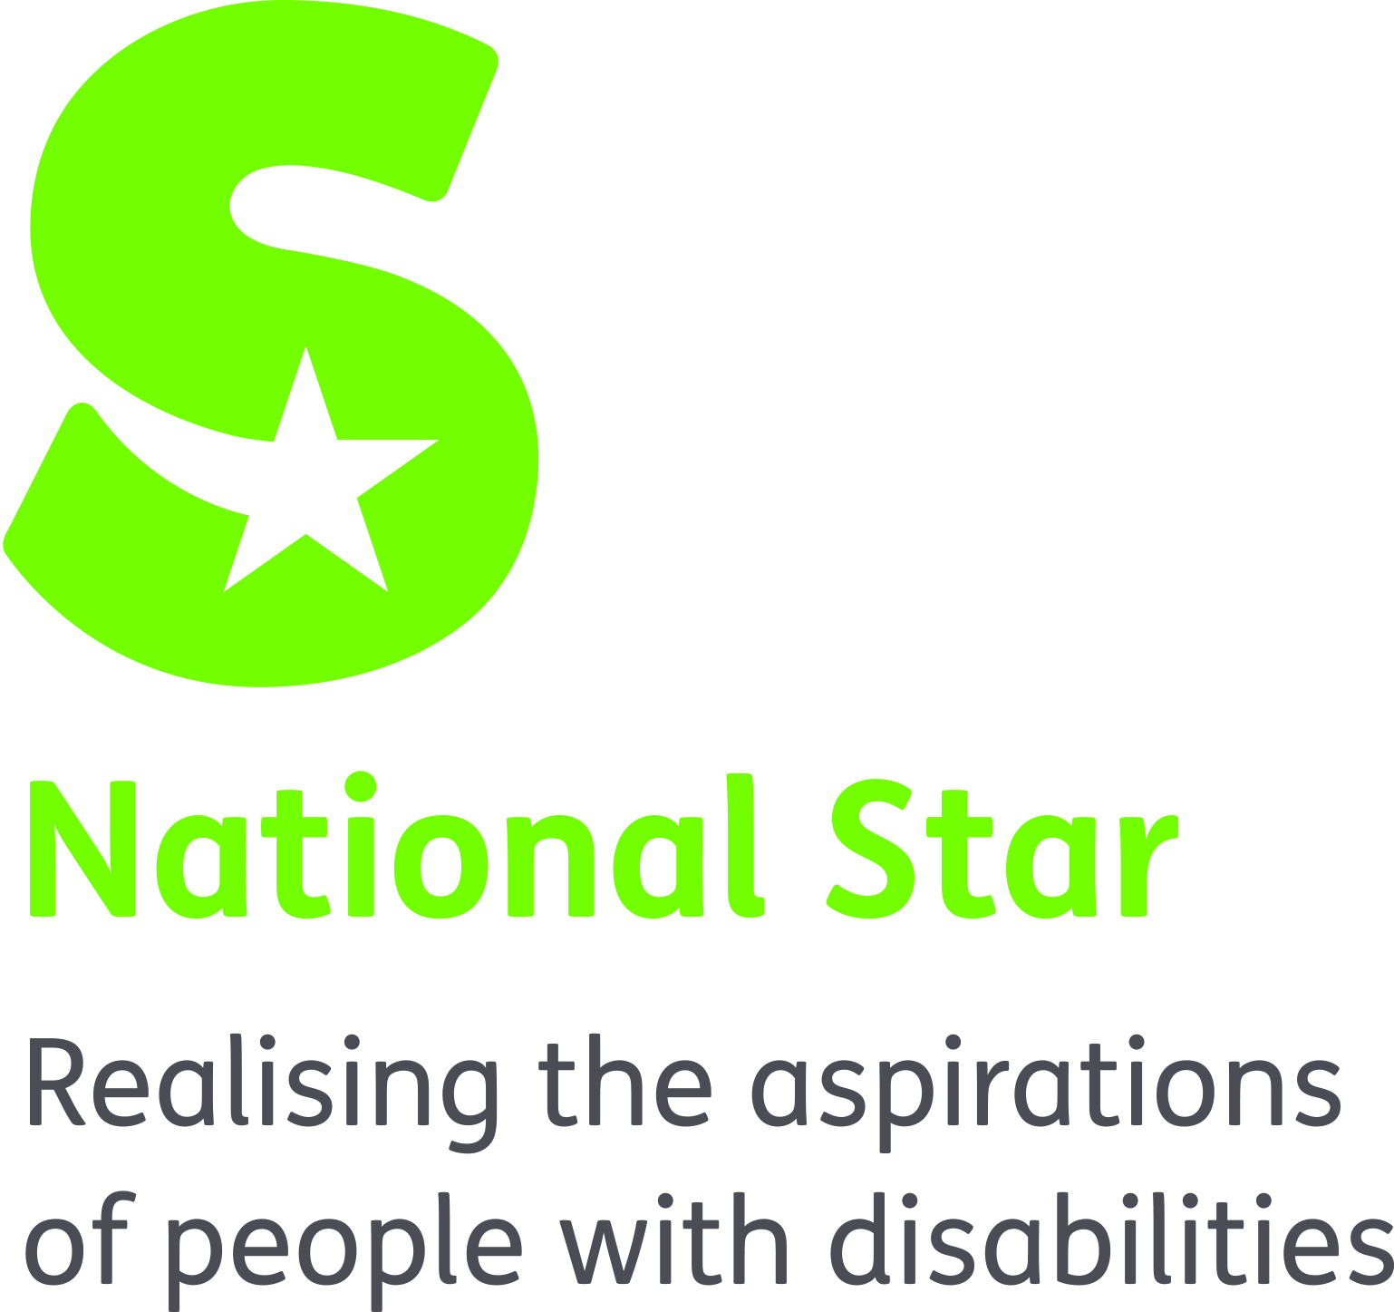
JOB DESCRIPTION

SENIOR PHYSIOTHERAPIST

ORGANISATION RESPONSIBILITIES:

Reports to: Physiotherapy Manager

Liaises with: Students/parents/carers
Residential and Educational staff
Allied Health Professionals
College Medical Officer
External Agencies

Supervises: Junior Therapists and Therapy Assistants

MAIN PURPOSE OF JOB:
To work as an integral member of the Physiotherapy team, delivering high quality therapeutic interventions to promote students learning and supporting their health and wellbeing. To supervise and support other members of the physiotherapy team and take an active role in the Senior Physiotherapist team.

PRIMARY TASKS:
- To assess, plan, implement and evaluate physiotherapy programmes to ensure students’ ongoing health and wellbeing and promote students learning. Ensuring interventions are safe, effective and meeting individual’s needs.

- To work as part of a multi-disciplinary team to meet the needs and improve the outcomes of students with varied physical and learning difficulties.

- To work with students, carers and members of the multi-disciplinary team to integrate therapy programmes into learning or other activities wherever possible. This include working in diverse environments including the Aquatic Therapy pool, fitness suite, rebound therapy educational groups etc.

- To oversee the work of Junior Physiotherapists and provide on-going supervision for junior Physiotherapists, Physiotherapy students and Physiotherapy Assistants, in line with college and professional policies and standards, assessing and evaluating competence when required.

- To be responsible for the ongoing management of your own caseload and quality assuring practice.

- To keep accurate and timely records in accordance with organisational and professional legislation, protocols and guidelines.

- To comply with all National Star policies and procedures and professional codes of practice as defined by the Chartered Society of Physiotherapy (CSP).

- To undertake relevant training to maintain and develop best practice and meet professional registration and student needs.

- To contribute to training, coaching and mentoring of staff in developing best working practices within the Physiotherapy Team and wider organisational teams.

- To communicate information in an understandable format for students, their carers, members of the multi-disciplinary team and outside agencies.

- To work one evening a week as needed to cover private therapy.

- To create, maintain and enhance productive working relationships with: students, the multi-disciplinary team, internal and external agencies, voluntary organisations and families and carers.

- To participate in National Star’s self-assessment processes and the review of organisational policies and procedures as required.

- To undertake other duties that may be within the scope of the role function.

SAFEGUARDING
National Star takes seriously its responsibility for safeguarding and is committed to safeguarding and promoting the welfare of adults at risk and children. Therefore we require that all staff share this and act accordingly by applying organisation policy and procedure and attending annual safeguarding training.

Equality & Diversity
Through personal example and clear action demonstrate commitment to equality and diversity ensuring equality of access and treatment in employment and service delivery to all.

Health & Safety
Promote National Star’s Health and Safety at Work Policy and Procedure and ensure these are implemented effectively within the department.

This job description sets out a summary of key features of the role. It is not intended to be exhaustive and will be reviewed periodically to ensure it remains appropriate to the role.

NATIONAL STAR
SENIOR PHYSIOTHERAPIST
ATTRIBUTES | ESSENTIAL | DESIRABLE
QUALIFICATIONS AND REGISTRATION | - BSc Physiotherapy,  - HCPC Registered  - Member of CSP | - Clinical supervision  Teaching, coaching, mentoring
EXPERIENCE | - 2 + years post-qualification experience in relevant field  - Effective Management of own work load/client group  - Working with young adults with complex physical and learning difficulties  - Support and guidance to junior therapists or therapy assistants  - Keeping written and electronic records of therapeutic interventions | - 4 + years post qualification experience  - Post registration specialist experience in relevant areas:  - Paediatrics  - Respiratory  - Rehabilitation  - Neurology  - Special needs  - Aquatic Therapy  - Rebound Therapy  - Application of supervision and appraisal processes  - Involvement in service development  - Familiarity with residential and/or educational settings  - Training staff  - MDT working
KNOWELDGE & SKILLS | - Ability to autonomously assess, plan, implement and evaluate therapy programmes  - Ability to manage diverse, complex therapeutic interventions to meet the needs of clients with complex physical and learning difficulties  - Ability to prioritise interventions caseloads  - Ability to be proactive and creative as a practitioner | - Specialist knowledge and skills in topics related to scope of practice  - Knowledge of Quality Assurance systems and processes  - Competencies in:  - Moving and Handling  - Risk Assessment  - Use of IT equipment  - Organising and  - Developing Group Therapies  - Lateral Thinking  - Motivation Techniques
PERSONAL | - Good team player  - Excellent communication skills (verbal and written)  - Punctual, reliable and organised  - Positive and proactive  - Practical an creative problem solver  - Flexible and adaptable  - Able to work under pressure  - Physically fit to meet the requirements of the role.  - Commitment to Equality & Diversity Support the ethos of National Star & be fit to work with adults at risk and children.
OTHER | - Able to meet the travel requirements of the post  - IT literate, able to use Microsoft Office: Word, Excel and PowerPoint  - Commitment to Equality & Diversity Support the ethos of National Star & be fit to work with vulnerable adults and children

